**CHAPTER 1**

**INTRODUCTION**

**1.1 Overview of Database Management System**

A database is an organized collection of [data](https://en.wikipedia.org/wiki/Data_(computing)). A relational database, more restrictively, is a collection of [schemas](https://en.wikipedia.org/wiki/Database_schema), tables, queries, reports, views, and other elements. Database designers typically organize the data to model aspects of reality in a way that supports processes requiring information, such as (for example) modelling the availability of rooms in hotels in a way that supports finding a hotel with vacancies.

This definition is part of our Essential Guide: [Relational database management system guide: RDBMS still on top](http://searchdatamanagement.techtarget.com/essentialguide/Relational-database-management-system-guide-RDBMS-still-on-top). A database management system (DBMS) is system software for creating and managing [databases](http://searchsqlserver.techtarget.com/definition/database). The DBMS provides users and programmers with a systematic way to create, retrieve, update and manage [data](http://searchdatamanagement.techtarget.com/definition/data) . A DBMS makes it possible for end users to create, read, update and delete [data](http://searchdatamanagement.techtarget.com/definition/data) in a database. The DBMS essentially serves as an interface between the [database](http://searchsqlserver.techtarget.com/definition/database) and end users or [application programs](http://searchsoftwarequality.techtarget.com/definition/application-program), ensuring that data is consistently organized and remains easily accessible.

The DBMS manages three important things: the data, the database [engine](http://whatis.techtarget.com/definition/engine) that allows data to be accessed, locked and modified -- and the database [schema](http://searchsqlserver.techtarget.com/definition/schema), which defines the database’s logical structure. These three foundational elements help provide [concurrency](http://searchoracle.techtarget.com/definition/concurrent-processing), security, [data integrity](http://searchdatacenter.techtarget.com/definition/integrity) and uniform administration procedures. Typical database administration tasks supported by the DBMS include [change management](http://searchcio.techtarget.com/definition/change-management), performance monitoring/tuning and [backup](http://searchstorage.techtarget.com/definition/backup) and [recovery](http://searchstorage.techtarget.com/definition/recovery). Many database management systems are also responsible for automated [rollbacks](http://searchsqlserver.techtarget.com/definition/rollback), restarts and recovery as well as the [logging](http://whatis.techtarget.com/definition/log-log-file) and [auditing](http://searchcio.techtarget.com/definition/audit-trail) of activity.

The two main early navigational data models were the [hierarchical model](https://en.wikipedia.org/wiki/Hierarchical_database_model), epitomized by IBM's IMS system, and the [CODASYL](https://en.wikipedia.org/wiki/CODASYL) model ([network model](https://en.wikipedia.org/wiki/Network_model)), implemented in a number of products such as [IDMS](https://en.wikipedia.org/wiki/IDMS).

The [relational model](https://en.wikipedia.org/wiki/Relational_model), first proposed in 1970 by [Edgar F. Cod](https://en.wikipedia.org/wiki/Edgar_F._Codd)ed, departed from this tradition by insisting that applications should search for data by content, rather than by following links. The relational model employs sets of ledger-style tables, each used for a different type of entity. Only in the mid-1980s did computing hardware become powerful enough to allow the wide deployment of relational systems (DBMSs plus applications). By the early 1990s, however, relational systems dominated in all large-scale [data processing](https://en.wikipedia.org/wiki/Data_processing) applications, and as of 2015 they remain dominant: [IBM DB2](https://en.wikipedia.org/wiki/IBM_DB2), [Oracle](https://en.wikipedia.org/wiki/Oracle_database), [MySQL](https://en.wikipedia.org/wiki/MySQL), and [Microsoft SQL Server](https://en.wikipedia.org/wiki/Microsoft_SQL_Server) are the top [DBMS](https://en.wikipedia.org/wiki/DBMS). The dominant database language, standardized SQL for the relational model, has influenced database languages for other data models.

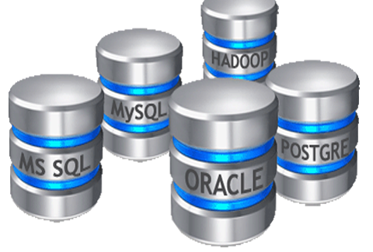

**Fig 1.1:** Sample figure of Database

The DBMS is perhaps most useful for providing a centralized view of data that can be accessed by multiple users, from multiple locations, in a controlled manner. A DBMS can limit what data the end user sees, as well as how that end user can view the data, providing many views of a single database schema. End users and software programs are free from having to understand where the data is physically located or on what type of storage media it resides because the DBMS handles all requests.

**1.2 Applications of a DBMS**

Using a DBMS to store and manage data comes with advantages, but also overhead. One of the biggest advantages of using a DBMS is that it lets end users and application programmer access and use the same data while managing data integrity. Data is better protected and maintained when it can be shared using a DBMS instead of creating new iterations of the same data stored in new files for every new application. The DBMS provides a central store of data that can be accessed by multiple users in a controlled manner.

Central storage and management of data within the DBMS provides:

* Data security
* Data abstraction and independence
* A locking mechanism for concurrent access
* The ability to swiftly recover from crashes and errors, including restartability and recoverability
* Robust data integrity capabilities
* Logging and auditing of activity
* Simple access using a standard application programming interface (API)
* Uniform administration procedures for data

Another advantage of a DBMS is that it can be used to impose a logical, structured organization on the data. A DBMS delivers economy of scale for processing large amounts of data because it is optimized for such operations.

**1.3 Introduction to inventory management system**

Inventory can be defined in several ways as follows as given below:

Inventory is the stock of physical items such as materials, components, work-in-progress, finished goods, etc., held at a specific location at a specific time.Inventory is a merchandise that is purchased and produced and stored for eventual sale.

Inventory is a list of what you have. In company accounts, inventory usually refers to the value of stocks, as distinct from fixed assets. An inventory would include items which are held for sale in the ordinary course of business or which are in the process of production for the purpose of sale, or which are to be used in the production of goods or services which will be for sale

**1.4 Scope of project**

* **Manage Inventory**: Inventory management helps to manage the stock of the company. it provides proper details of the products what kind of raw material, what are the sizes we require and etc. to the purchasing department
* **Less Storage**: When the inventory management provides proper information to management, they buy according to them which helps the company to store fewer products.
* **Improve Productivity**: Inventory management helps to improve the productivity of the machines and manpower. Employees are aware of stocks and the quantity that require to produce.
* **Increase Profits**: Inventory management helps to improve the profits of the company. it helps to provide proper information about stocks, that saves the unnecessary expenses on stocks.

**1.5 Advantages of inventory management system**

* **Manage Inventory**: Inventory management helps to manage the stock of the company. it provides proper details of the products what kind of raw material, what are the sizes we require and etc. to the purchasing department.
* **Less Storage**: When the inventory management provides proper information to management, they buy according to them which helps the company to store fewer products.
* **Improve Productivity:** Inventory management helps to improve the productivity of the machines and manpower. Employees are aware of stocks and the quantity that require to produce.
* **Increase Profits:** Inventory management helps to improve the profits of the company. it helps to provide proper information about stocks, that saves the unnecessary expenses on stocks.

**CHAPTER 2**

**REQUIREMENT SPECIFICATION**

System Analysis refers into the process of examining a situation with the intent of improving it through better procedures and methods. System Analysis is the process of planning a new System to either replace or complement an existing system. But before any planning is done the old system must be thoroughly understood and the requirements determined. System Analysis is therefore, the process of gathering and interpreting facts, diagnosing problems and using the information to re-comment improvements in the System. Or in other words, System Analysis means a detailed explanation or description. Before computerized a system under consideration, it has to be analyzed. We need to study how it functions currently, what are the problems, and what are the requirements that the proposed system should meet.

**System Analysis**

Every Software development requires the survey process. The Survey process is needed to get the requirement for the software. The Survey also consists of studying the present system and also studying about the tools needed for the development of the software. A proper understanding of the tools is very much essential. Following is an extract of the information of the material collected during literature survey.

**2.1 Hardware Requirement.**

⇨ Processor

▪ Intel Core 2 duo (minimum)

▪ Intel Core i3 and above (recommended)

⇨ RAM

▪ 1GB (minimum)

▪ 4GB (recommended)

⇨ Disk Space

▪ 10GB (minimum)

▪ 20GB (recommended)

**2.2 Software Requirements**

⇨ Operating System

▪ Windows 7

⇨ Front End

▪ HTML & CSS

⇨ Back End

▪ MYSQL

**2.3 System Requirements**

* Personal computer
* Web browser.

**2.4 User Requirements**

* User should be able to use computer.
* One should have English knowledge to understand.

**CHAPTER 3**

**SYSTEM DESIGN**

System design is the process of defining the architecture, dataflow chart, module diagram, ER diagram etc. High level design is the design which is plotted for designing the software related items. Here the complete system design is generated and how the data flow diagram, ER diagram between them data flow is initialized. It is very simple phase but the base phase for any of the actual implementation process. The errors done here will be satisfied in the coming process.

**3.1 System Architecture**

The large system is decomposed into sub-systems that provide some related set of services. Thus, architecture design is the initial design process of identifying these sub-systems and establishing a framework for the sub-system control and communications. As part of the architectural design process, some of the activities such as system structuring are usually necessary.

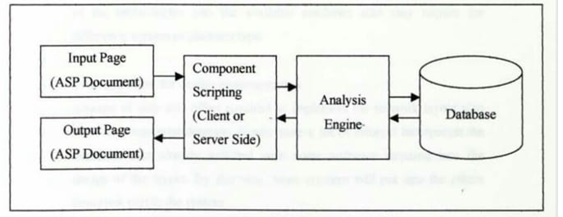

**Fig 3.1:** System Architecture

Systematic and rigorous approach to design such a system which fulfills all the System design is the process of defining the elements of the system such as the architecture, modules and components, the different interfaces of those components and the data that goes through that system. It is meant to satisfy specific needs and requirements of a business or organization through the engineering of a coherent and well-running system. System designing in terms of software engineering has its own value and importance in the system development process as a whole. To mention it may though seem as simple as anything or simply the design of systems, but in a broader sense it implies practical aspects including flexibility, efficiency and security. Before there is any further discussion of system design, it is important that some points be made clear. As it goes without saying that nothing is created that is not affected by the world in which it’s made. So, the systems are not created in a vacuum. They are created in order to meet the needs of the users. They are not only intended to solve the existing problems, but they also come up with acceptable solutions to the problems that may arise in the future.

The whole process of system development, from blueprint to the actual product, involves consider in all the relevant factors and taking the required specifications and creating a useful system based on strong technical, analytical and development skills of the professionals. The importance of this phase may be understood by reason of the fact that it involves identifying data sources, the nature and type of data that is available. For example, in order to design a salary system, there is need for using inputs, such as, attendance, leave details, additions or deductions etc. This facilitates understanding what kind of data is available and by whom it is supplied to the system so that the system may be designed considering all the relevant factors. In addition, system designing leads to ensure that the system is created in such a way that it fulfils the need of the users and keep them to ease being user-oriented. In terms of the flexibility, one of the main objectives of this phase is that it is intended to design such a system which can be dynamic in nature and responsive to the changes if required. Another important objective is that the phase of system designing is concerned with creating the systems which can work efficiently providing the required output and being responsive to the time within a given time limit. The aspect of reliability and physical security of data cannot be ignored. With this respect, the system designing phase ensures security measures of the system effectively and efficiently.

**3.2 Data Flow Diagram**

DFD graphically representing the functions, or processes, which capture, manipulate, store, and distribute data between a system and its environment and between components of a system. The visual representation makes it a good communication tool between User and System designer. DFD has often been used due to the following reasons:

* Logical information flow of the system
* Determination of physical system construction requirements
* Simplicity of notation
* Establishment of manual and automated systems requirement.

**3.3 ER Diagram and Schema Diagram:**

**● Entity Relationship Diagram**

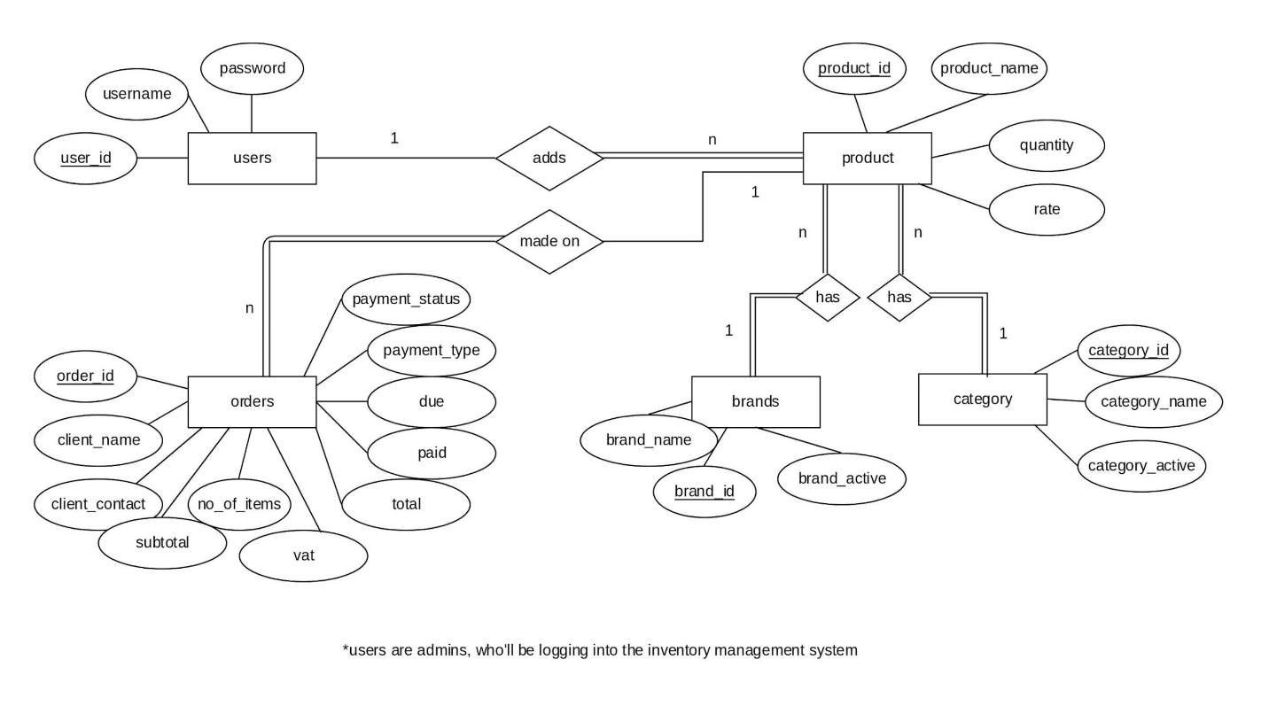

**Fig 3.2:** E-R diagram for Inventory Management System

Entity Relationship Diagram depicts the various relationships among entities, considering each objective as entity. Entity relationships are described by their dependence on each other, as well as the extent of the relationship between the data stores. It depicts the relationship between data objects. The ER diagram is a notation that is used to conduct the data modeling activity.

**● Schema diagram**

A database schema can be represented in a visual diagram, which shows the database objects and their relationship with each other. A schema contains schema objects, which could be tables, columns, data types, views, stored procedures, relationships, primary keys, foreign keys etc.

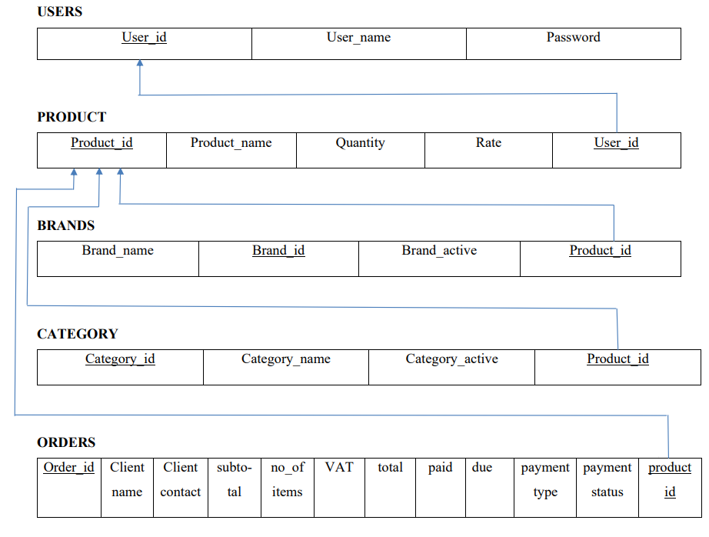

**Fig 3.3:** Schema diagram for Inventory Management System.

**CHAPTER 4**

**IMPLEMENTATION**

* 1. **Tools Used**

**Visual studio:** Windows is a graphical user interface (GUI) sometimes also called as visual interface of graphical windowing environment. All graphical user interfaces makes use of graphics on a built mapped video display. Graphics provide a better utilization of an even real state, a visually rich environment for copying information. The video display shows unions graphical objects and in the form of icons and input devices such as buttons.

**Evolution of HTML:** As you all are familiar with web pages and websites, do you know how these pages are created and displayed? Who started developing HTML language for sharing information on the World Wide Web (WWW) In this chapter, you will be learning about all these queries along with the skill of creating your web page.

HTML (Hypertext Markup Language) is the only markup language for creating web pages. It provides some titles, headings, paragraphs, lists, table, embedded images, etc. to describe the structure of text-based information in HTML documents.

**HTML Framework Architecture**

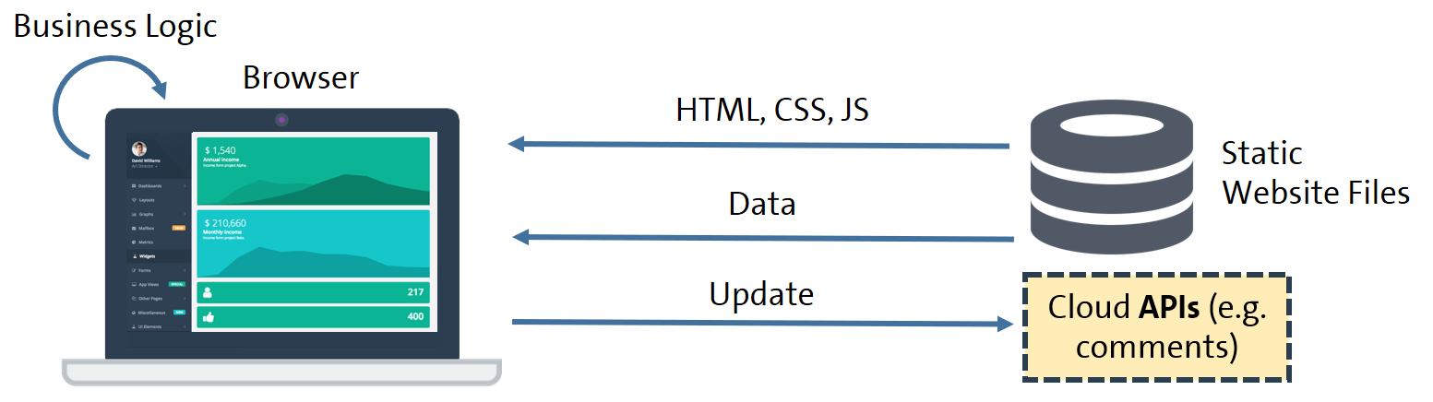 **Fig 5.1:** HTML Framework Architecture.

Hyper Text Markup Language (HTML) was the first tool with which people had begun to create web pages in olden times. HTML is a language that stylize text, create paragraphs and line breaks etc. But the most important thing that HTML does is link creation.

JavaScript became de facto scripting language of the web. Using a scripting language you can add a bit of dynamic element in static pages. If you’re a master JavaScript coder, *you can* create dynamic and very interactive web page using JavaScrip*t*. For a small example, with JavaScript you can make a random number to display every time an HTML web page loads in browser. But even such pages are called static pages!

The code of static web pages is downloaded in one go. When you load the web page –all the code (HTML, JavaScript, CSS) and other resources like images are downloaded in browser in one go.

# MYSQL:

# MySQL is an object relational data base management system. It offers capabilities of both relational and object oriented database system. In general object can be defined as reasonable software codes, which are location independent and perform a specific task on any application environment with little or no change. Oracle products are based on a concept knows are client’s server technology. This concept involves segregating the processing of the application between two systems. One performs all the activity related to database and the other performs the activity to interact with the application. A client or a font end data base application also interact with the database by requesting the user and the database further it also checks four validations against the data entered by the user. The commonly used front-end tools of MySQL are MySQL-Browser. MySQL Administrator and MySQL-Browser can't connect to MySQL Server 5.0.51a with local host, root access.

**4.2 Tables Description**

**Table name**: USERS

**Description:** It holds user information

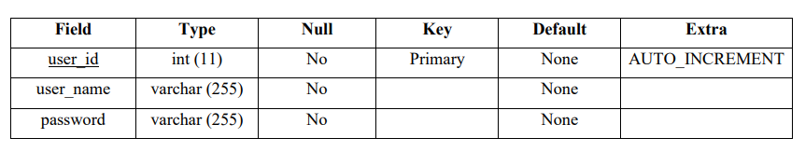**Table 4.2.1 :** Users Seciton

**Table Name:** PRODUCT

**Description:** It stores product information

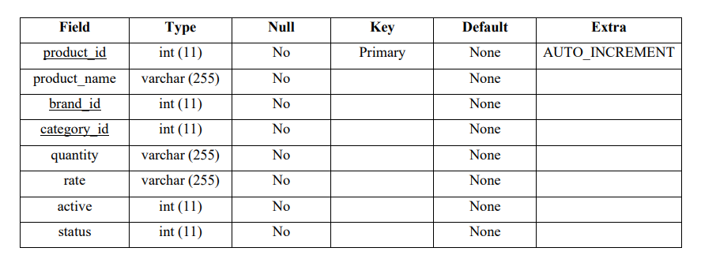

**Table 4.2.2 :** Product Section

**Table Name:** BRANDS

**Description:** It stores brand information

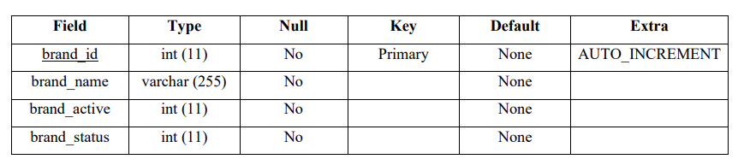

**Table 4.2.** **3 :** Brand Section

**Table Name:** CATEGORY

**Description:** It stores category information

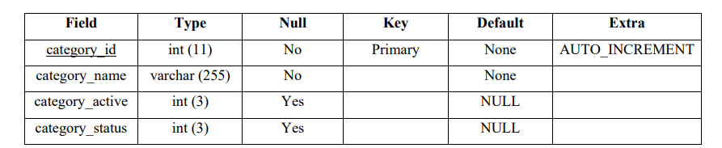

**Table 4.2.4 :** Category Section

**Table Name:** ORDERS

**Description:** It stores order information

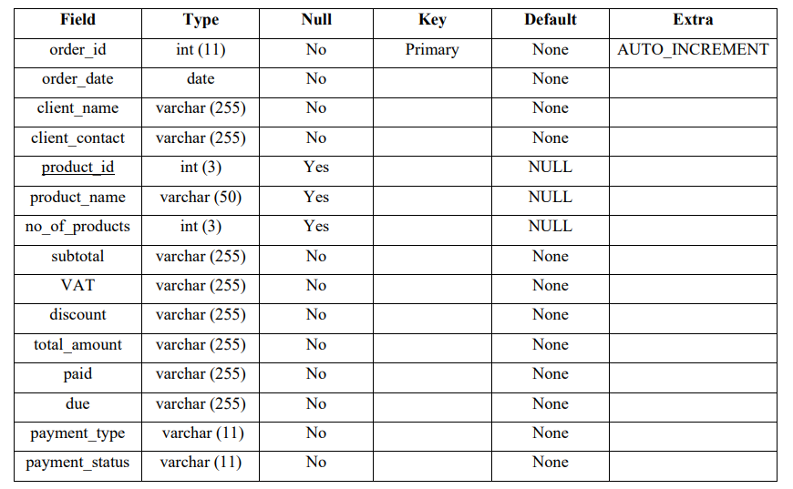**Table 4.2.5 :** Orders Section

**4.3 Modules Description**

* **Admin**

In this section a admin can log in and can get access to delete , update, insert an order, able to manage the payment details of every costumer.This inventory management dosen’t contain a user log in page because this project is just a admin accessed because this is about maintaining a inventory to a required e-commerce website .Inside this admin page there is a dashboard which keep on updating as we add a product, it displays number of product available, number of category available, number of brands available, total sales till date,Total amount collected, our total number of costumers, due payment, number of orders till date etc.

**CHAPTER 5**

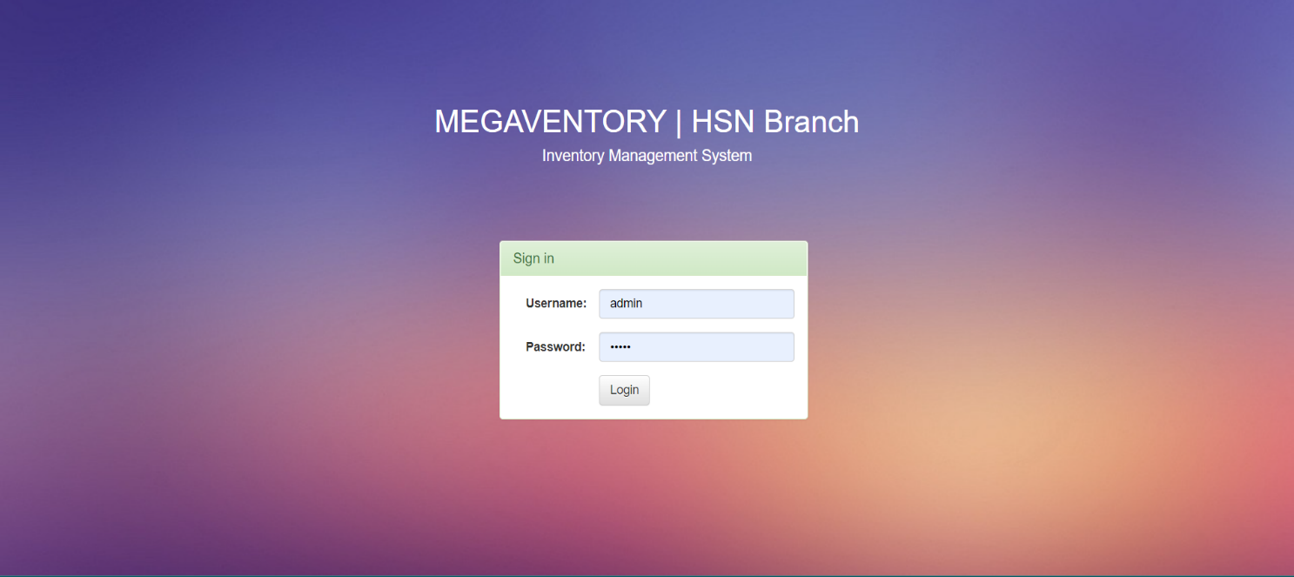**SNAPSHOTS**

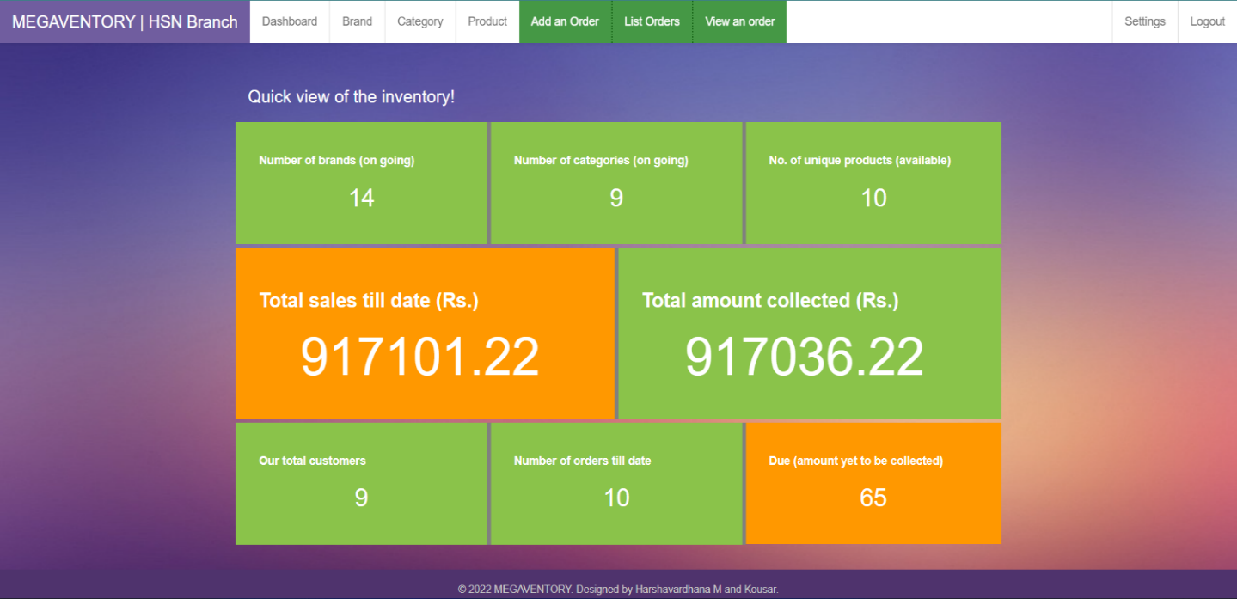**Snapshot.5.1:** Login page

**Snapshot.5.2:** Dashboard page

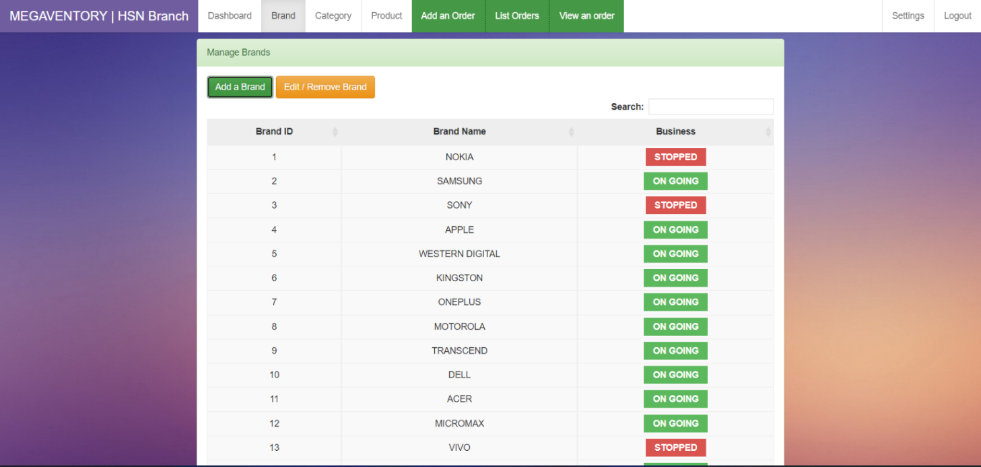**Snapshot.5.3:** Brand page

# 

**Snapshot.5.4:** Edit/Delete section of brand page

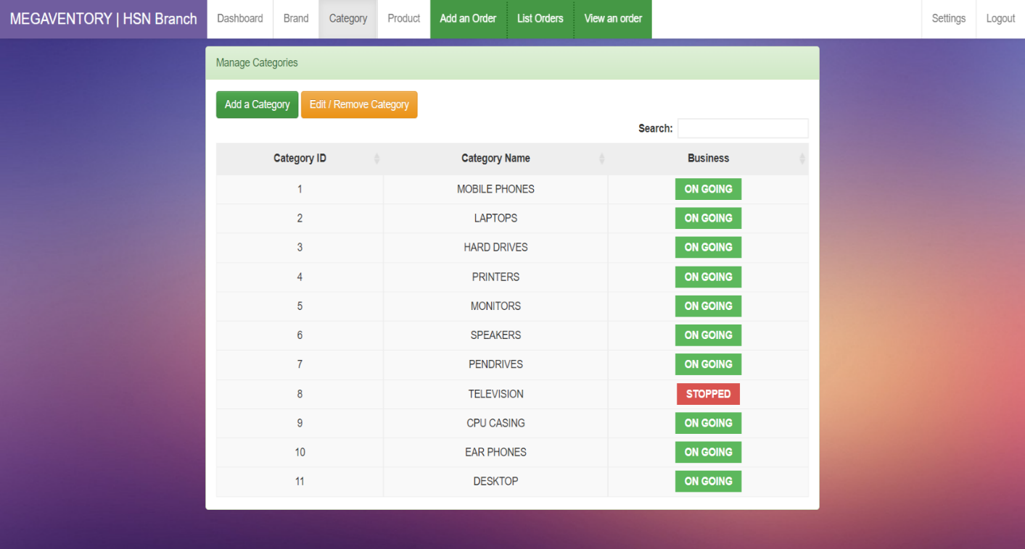

**Snapshot.5.5:** Add brand section of brand page

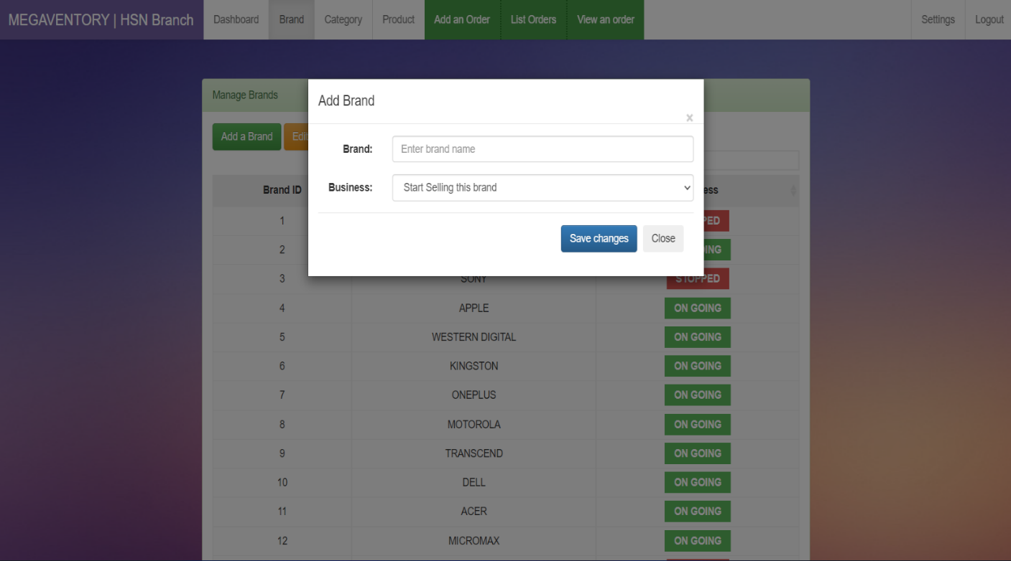

**Snapshot.5.6:** Category details

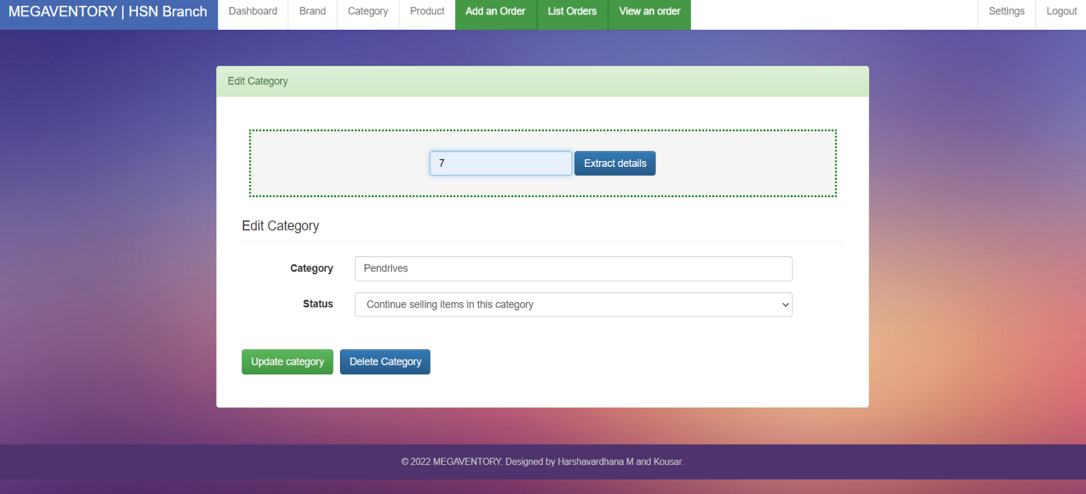

**Snapshot.** **5.7:** Add category section

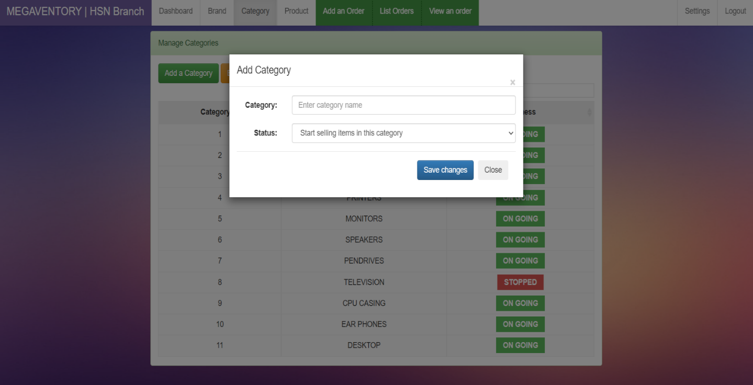

**Snapshot.5.8:** Update/Edit section of category

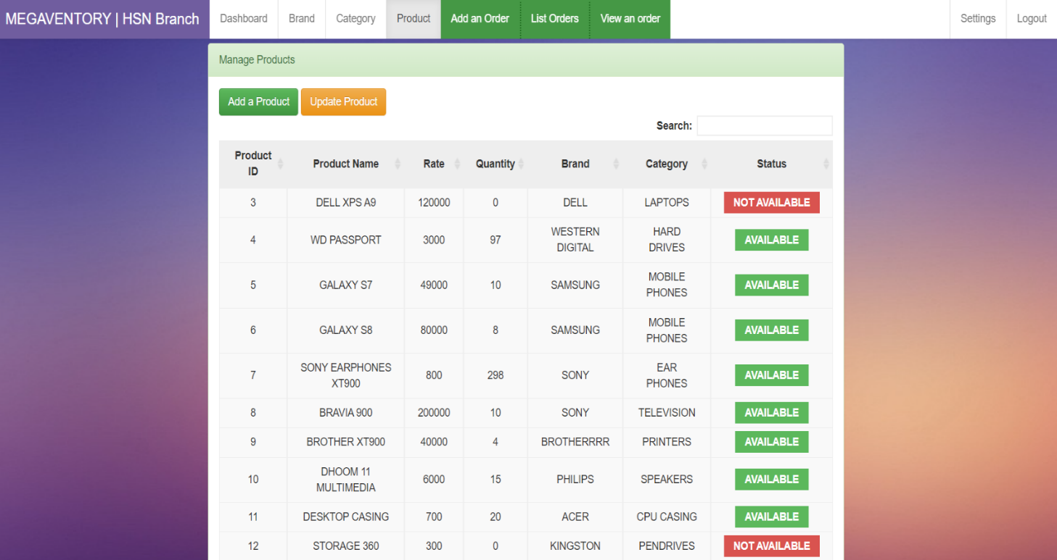

**Snapshot.5.9:** Product details

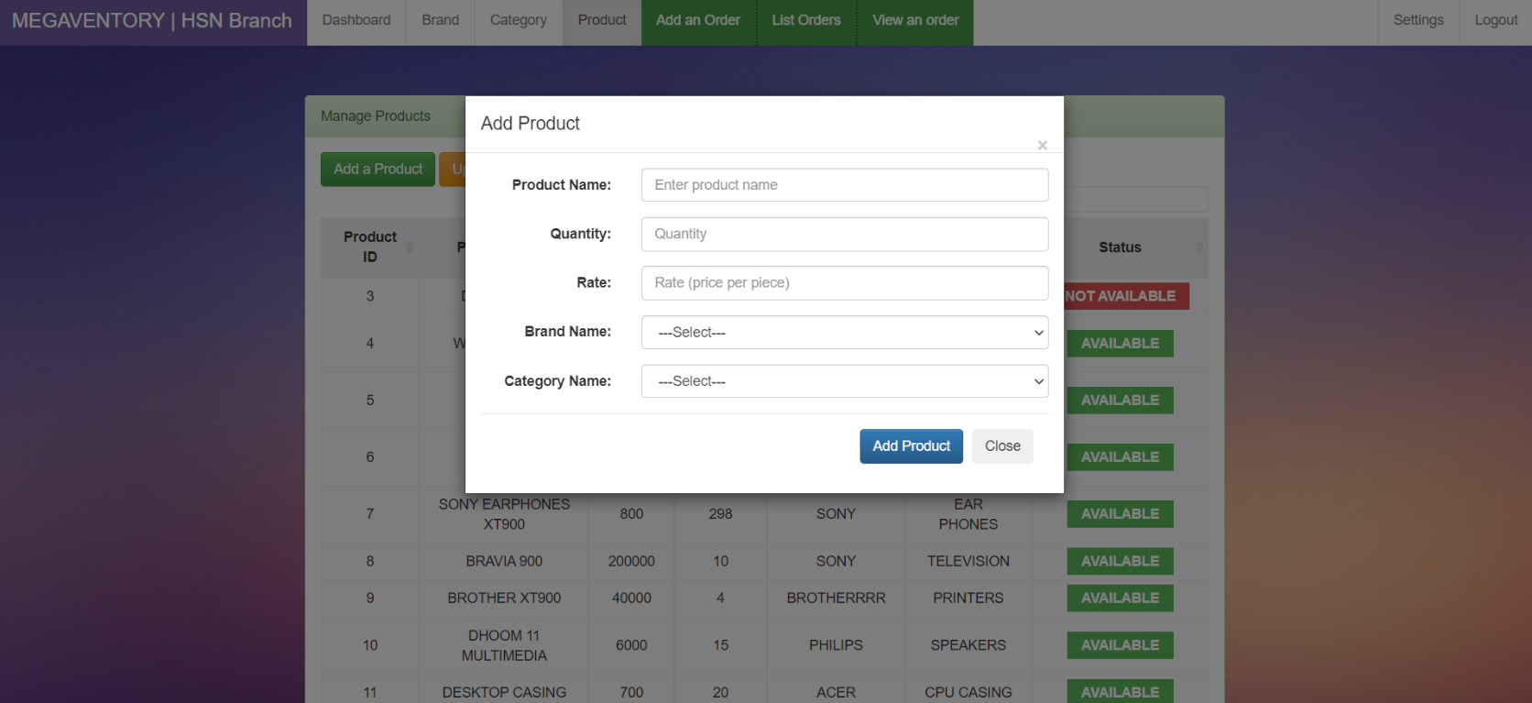

**Snapshot.5.10:** Add product section

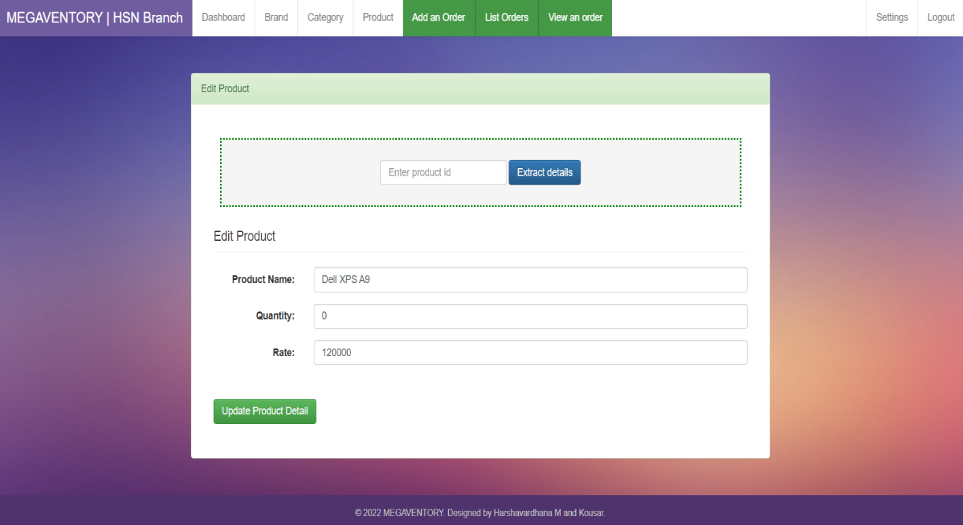

**Snapshot.5.11:** Edit product details section

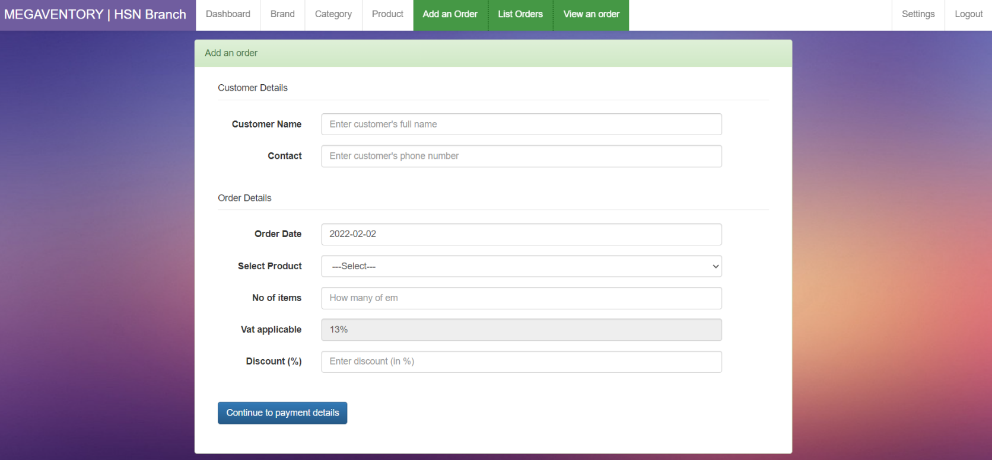

**Snapshot.5.12:** Add an order section

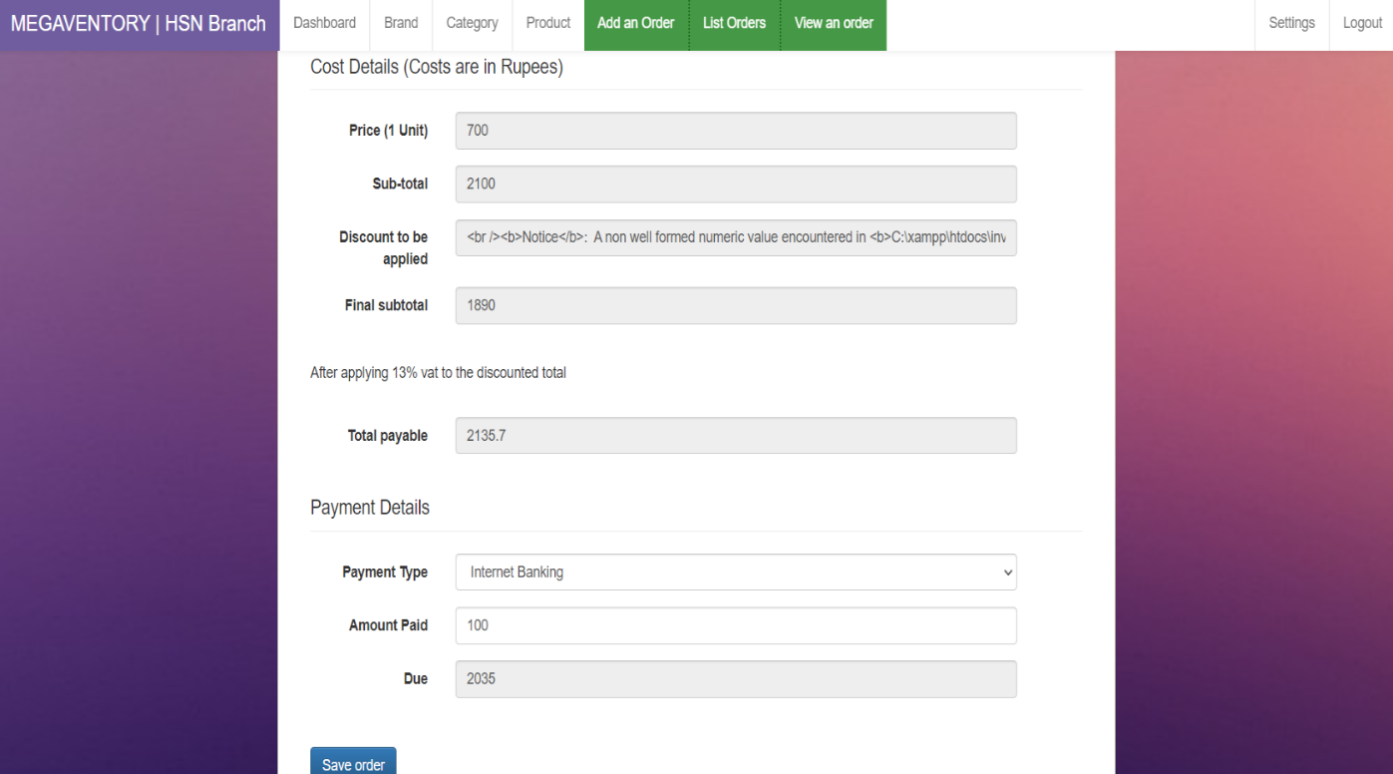

**Snapshot.5.13:** Payment details

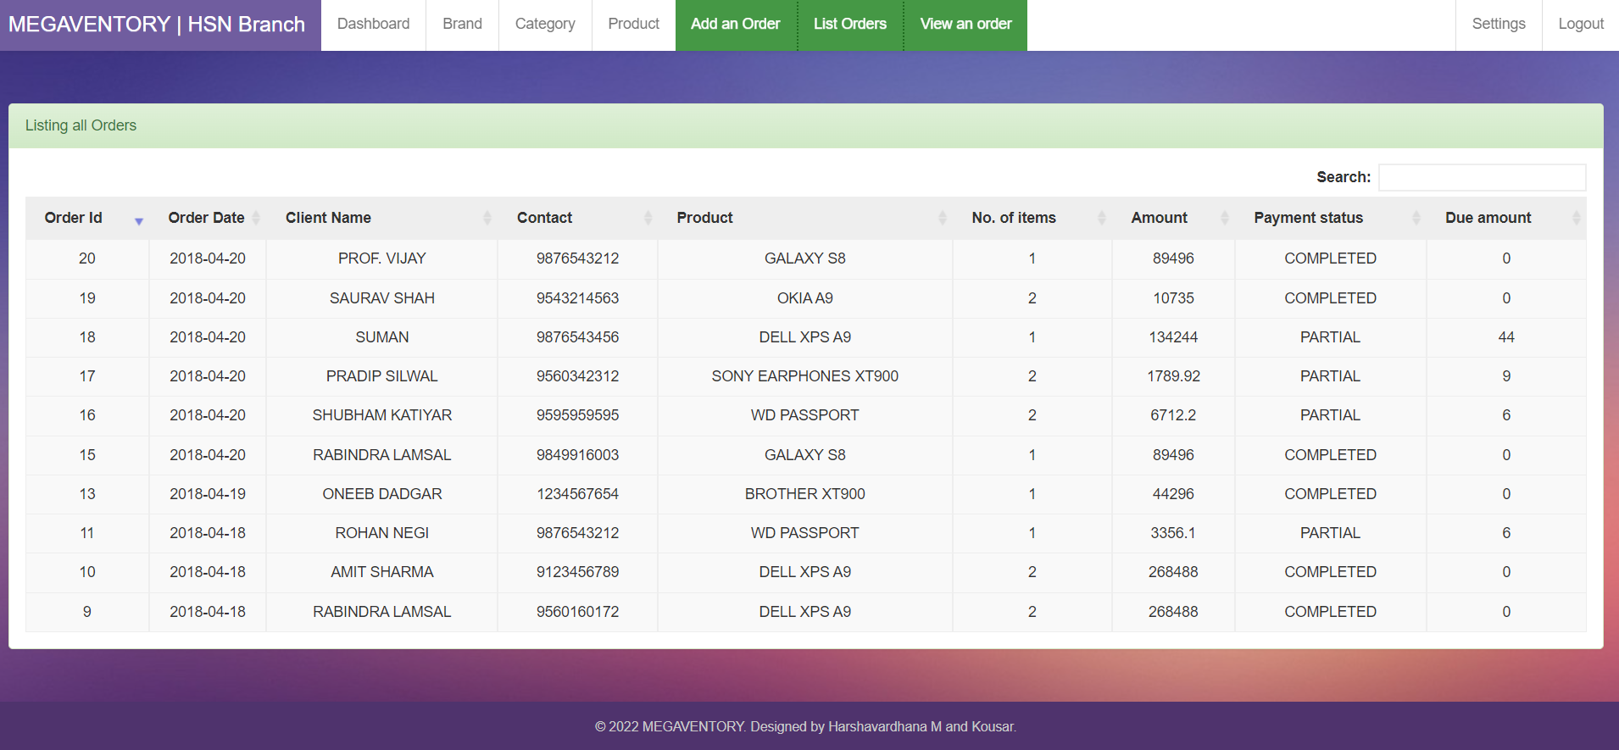

**Snapshot.5.14:** List of all the orders

## 

**Snapshot.5.15:** Order details

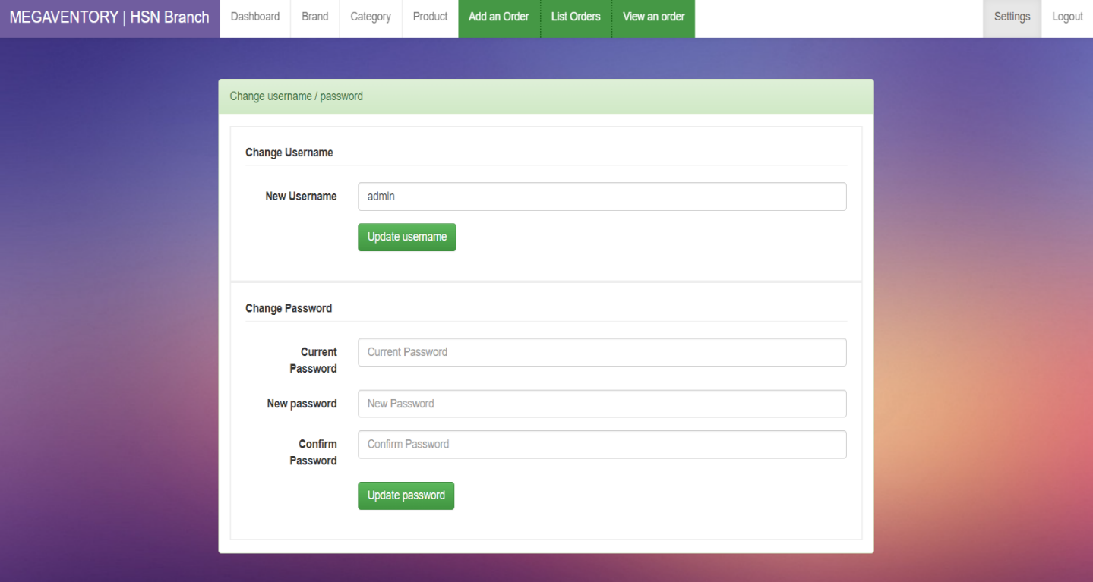

**Snapshot.5.16:** Change username/password interface

**FUTURE SCOPE**

Inventory management is a process of tracking the products. This includes all the inventory management until it reached to the final consumer. it includes finished products manufactured by the company and the raw material which may be required for production on finished goods.

* **Manage Inventory**: Inventory management helps to manage the stock of the company. it provides proper details of the products what kind of raw material, what are the sizes we require and etc. to the purchasing department.
* **Less Storage**: When the inventory management provides proper information to management, they buy according to them which helps the company to store fewer products.
* **Improve Productivity:** Inventory management helps to improve the productivity of the machines and manpower. Employees are aware of stocks and the quantity that require to produce.
* **Increase Profits:**Inventory management helps to improve the profits of the company. it helps to provide proper information about stocks, that saves the unnecessary expenses on stocks.

**CONCLUSION**

Inventory management has to do with keeping precise records of finished goods that are ready for shipment. This often means posting the production of newly completed goods to the inventory totals as well as subtracting the most recent shipments of finished goods to buyers. When the company has a return policy in place, there is usually a sub-category contained in the finished goods inventory to account for any returned goods that are reclassified or second grade quality. Accurately maintaining figures on the finished goods inventory makes it possible to quickly convey information to sales personnel as to what is available and ready for shipment at any given time.

The ROI of Inventory management will be seen in the forms of increased revenue and profits, positive employee atmosphere, and on overall increase of customer satisfaction. The next step of the present research will be the application of achieved results of demand forecasts, safety stock and reorder points into simulation software in order to achieve more accurate results.

**BIBLIOGRAPHY**

[1] L. Ling, Supply chain management: concepts, techniques and practices enhancing the value through collaboration. NJ: World Scientific, 2007. 372 p.

[2] M. Leseure, Key Concepts in Operations Management, 2010.

[3] D. Plinere, L. Aleksejeva, “Agent system application as a tool for inventory management improvement,” in 8th Int. Conf. on Soft Computing, Computing with Words and Perceptions in System Analysis, Decision and Control, 3–4 Sep., 2015. Antalya, Turkey, pp. 157–166.

[4] D.S. Plinere, A.N. Borisov, L. Ya. Aleksejeva, “Interaction of Software Agents in the Problem of Coordinating Orders,” Automatic Control and Computer Sciences, 2015, vol. 49, no. 5, pp. 268–276. http://dx.doi.org/10.3103/S0146411615050089

[5] D.C.U. Cadavid, C.C. Zuluaga, “A framework for decision support system in inventory management area,” Ninth LACCEI Latin American and Caribbean Conf., LACCEI’2011, Aug. 3–5, 2011, Medellin, Colombia.

[6] D. Dhoka, Y.L. Choudary “ABC Classification for Inventory Optimization,” IOSR Journal of Business and Management, vol. 15, Issue 1, Nov. – Dec. 2013, pp. 38–41. http://dx.doi.org/10.9790/487X- 1513841

[7] Life cycle engineering [Online] Available: http://www.lce.com/pdf/ abcclassification.pdf [Accessed: Sept. 25, 2015]

[8] ABC analysis (Inventory) By Joffrey Collignon, Joannes Vermorel, Feb. 2012 [Online] Available: http://www.lokad.com/abc-analysis- (inventory)-definition [Accessed: Sept. 25, 2015]

[9] ABC Inventory Analysis using Excel. Posted on October 1st, 2014. [Online] Available: http://chandoo.org/wp/2014/10/01/abc-inventory-analysis-using-excel [Accessed: Sept. 25, 2015]

[10] [www.reportgallery.com](http://www.reportgallery.com)

[11] www.sebi.in